**INTRODUCTION TO PYTHON**

Q1) Write a Python script to test if a number is prime or not?

- The Script name: primes.py

- Add a functions is_prime() which return boolean True or False

- Program should accept a number from console

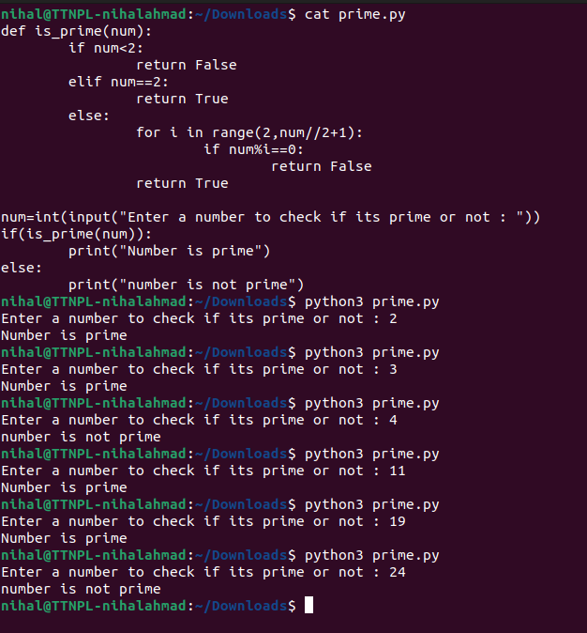

Q2) Write a code to print binary, octal or hexa-decimal presentation of a number. Do not use any third party library.

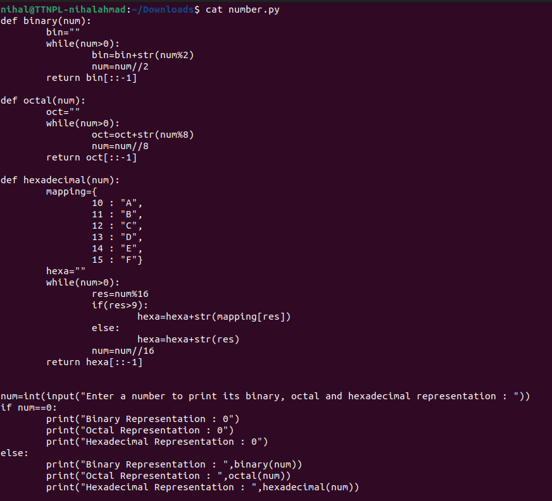

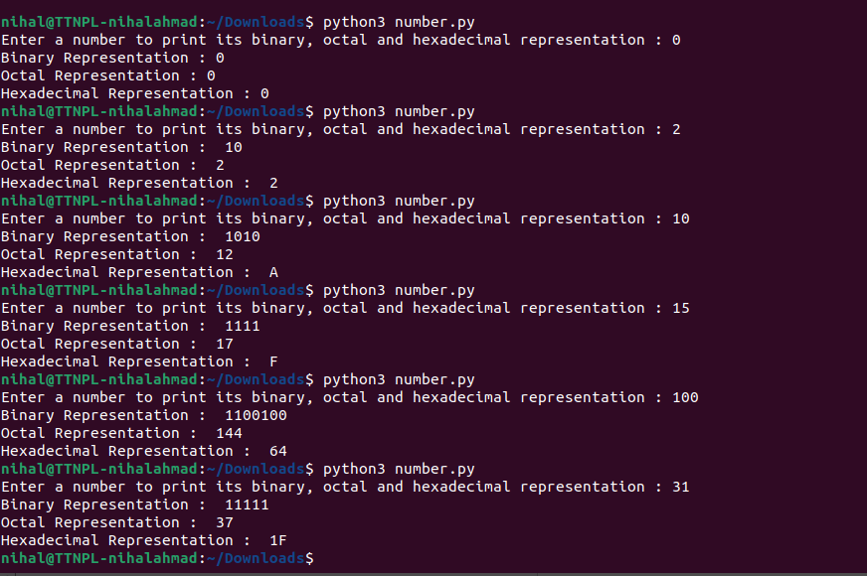

**PPT QUESTIONS:**

1. Given string my_string = ‘Hello Python!’, Reverse the string using slicing, print ’!’ using indexing

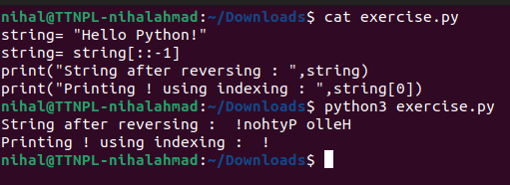

1. Use slicing to get word “frain” from “information”.

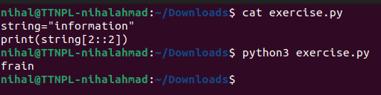

1. Using examples explain string.format and f-strings

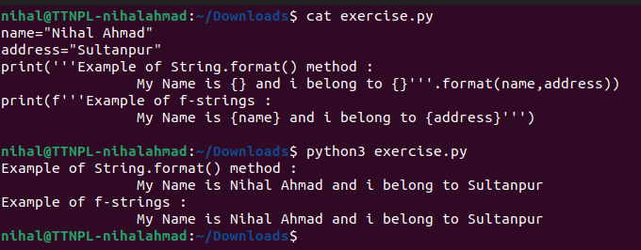

1. Can we sort a dictionary? Why or why not?

Yes , we can sort a dictionary. We can use the following method to display the sorted value of the dictionary using the keys of the given dictionary.

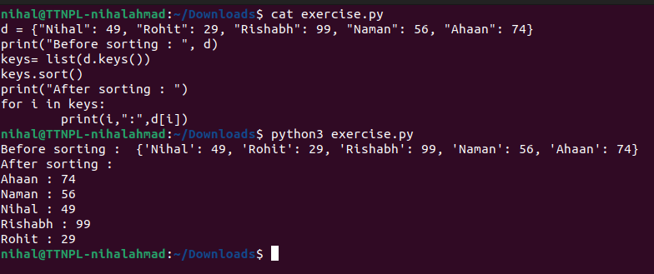

1. Using keys and indexing, grab the 'hello' from the following dictionaries:

● d = {'simple_key':'hello'}

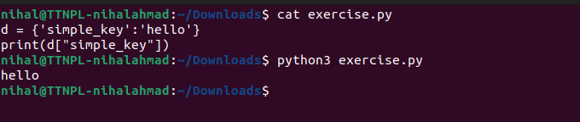

● d = {'k1':{'k2':'hello'}}

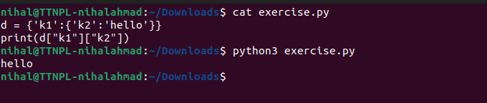

● d = {'k1':[{'nest_key':['this is deep',['hello']]}]}

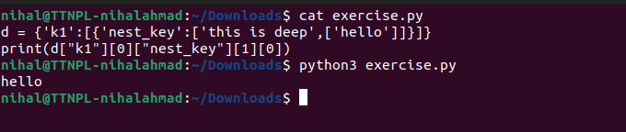

● d = {'k1':[1,2,{'k2':['this is tricky',{'tough':[1,2,['hello']]}]}]}

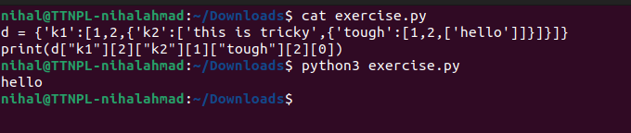

1. Reassign 'hello' in this nested list to say 'goodbye' instead:

list3 = [1,2,[3,4,'hello']]

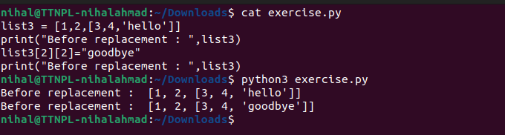

1. From the given list list5 create a set

list5 = [1,2,2,33,4,4,11,22,3,3,2]

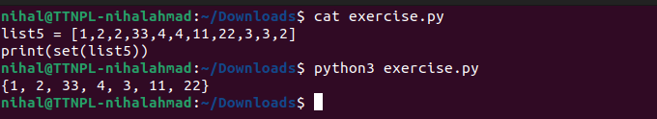

1. In string information count the total number of i.

**Method-1:**

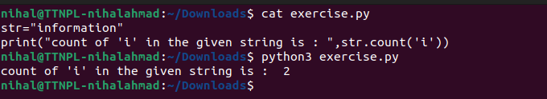

**Method-2:**

